IOT Office Automation

It is quite difficult for individual office owners to operate one or more that one Offices and keep track of each office appliances individually. At such time we need an online solution for physical office appliances control. Her we propose use of IOT technology for office appliance automation. This allows owner co control his/her office appliances through the internet using an easy to use GUI. For this system demonstration our system uses an AVR family microcontroller for the purpose.
A WIFI modem is used for receiving commands over the internet. We use 3 loads and a fan to demonstrate as office loads. A WIFI modem is used to receive commands over the internet. The WIFI module receives user commands over the internet. This information is then passed on n to the microcontroller. The microcontroller now processes this data and switches the loads through relays.
Also it switches the fan as per Users commands. Also it displays the status of the system on an LCD screen. Thus office automation system allows user to control his office remotely using IOT technology.

Block Diagram:

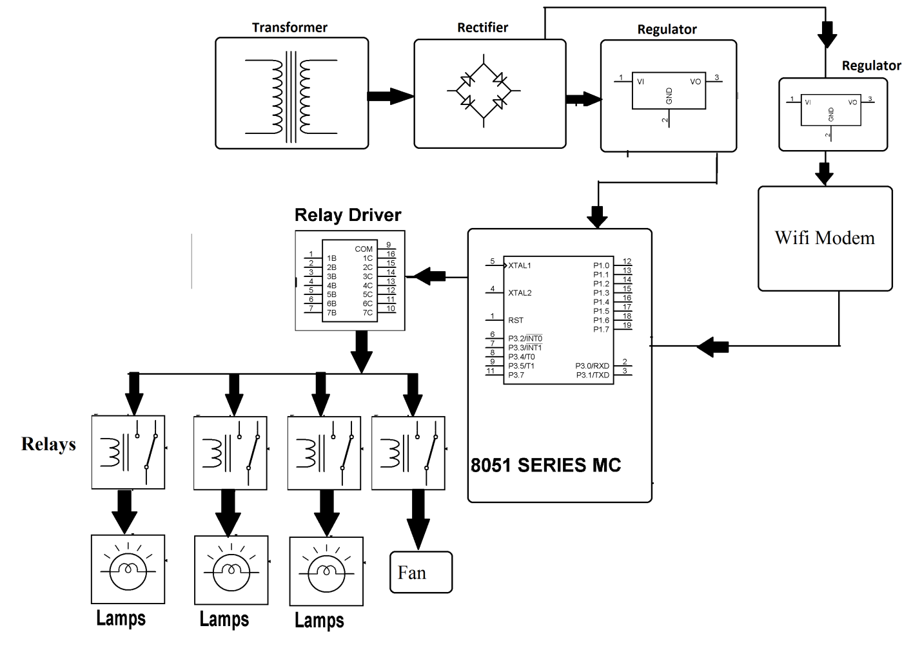

Hardware Specifications
- 8051 series Microcontroller
- Wifi Modem
- Diodes
- Transformer
- Relays
- Voltage Regulator
- Crystal
- Lamps
- LED
- Relay Driver IC

Software Specifications
- Keil µVision IDE
- MC Programming Language: Embedded C

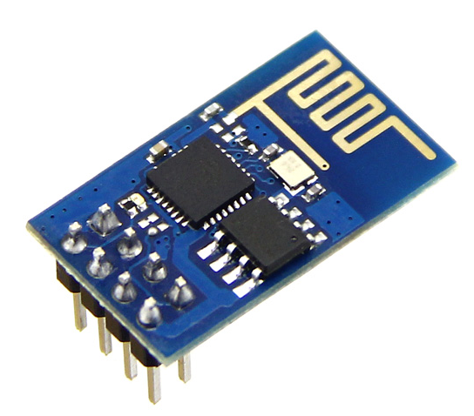
WIFI Modem:
The ESP8266 WiFi Module is a self contained SOC with integrated TCP/IP protocol stack that can give any microcontroller access to your WiFi network. The ESP8266 is capable of either hosting an application or offloading all Wi-Fi networking functions from another application processor. Each ESP8266 module comes pre-programmed with an AT command set firmware. The ESP8266 module is an extremely cost effective board with a huge, and ever growing, community.
This module has a powerful enough on-board processing and storage capability that allows it to be integrated with the sensors and other application specific devices through its GPIOs with minimal development up-front and minimal loading during runtime. Its high degree of on-chip integration allows for minimal external circuitry, including the front-end module, is designed to occupy minimal PCB area. The ESP8266 supports APSD for VoIP applications and Bluetooth co-existance interfaces, it contains a self-calibrated RF allowing it to work under all operating conditions, and requires no external RF parts.
There is an almost limitless fountain of information available for the ESP8266, all of which has been provided by amazing community support. In the Documents section below you will find many resources to aid you in using the ESP8266, even instructions on how to transforming this module into an IoT (Internet of Things) solution!
Note: The ESP8266 Module is not capable of 5-3V logic shifting and will require an external Logic Level Converter. Please do not power it directly from your 5V dev board.

Features:
802.11 b/g/n
Wi-Fi Direct (P2P), soft-AP
Integrated TCP/IP protocol stack
Integrated TR switch, balun, LNA, power amplifier and matching network
Integrated PLLs, regulators, DCXO and power management units
+19.5dBm output power in 802.11b mode
Power down leakage current of <10uA
1MB Flash Memory
Integrated low power 32-bit CPU could be used as application processor
SDIO 1.1 / 2.0, SPI, UART
STBC, 1×1 MIMO, 2×1 MIMO
A-MPDU & A-MSDU aggregation & 0.4ms guard interval
Wake up and transmit packets in < 2ms
Standby power consumption of < 1.0mW (DTIM3)

Reference
- http://ieeexplore.ieee.org/xpl/articleDetails.jsp?arnumber=7096250&queryText=iot%20office&newsearch=true

